University Of Engineering and Technology, Lahore
Computer Engineering Department

Course Name: Programming Fundamentals | Course Code: CMPE-112L
Assignment Type: Lab Report | Dated:
Semester: 1st | Session: 2026 Spring
Lab/Project/Assignment #: 5 | CLOs to be covered: CLO
Lab Title: Functions | Teacher Name: Hafiz Muhammad Mubashar
Lab Evaluation:

CLO1 | Apply appropriate programming techniques to create executable programs to solve well defined problems
 | Level1 | Level2 | Level3 | Level4 | Level5 | Level6
(5)
Total |  |  |  |  |  | /5
Rubrics for Current Lab Evaluation
Scale | Marks | Level | Rubric
Excellent | 5 | L1 | Submitted all lab tasks, BONUS task, have good understanding.
Very Good | 4 | L2 | Submitted the lab tasks but have good understanding
Good | 3 | L3 | Submitted the lab tasks but have weak understanding.
Basic | 2 | L4 | Submitted the lab tasks but have no understanding.
Barely Acceptable | 1 | L5 | Submitted only one lab task.
Not Acceptable | 0 | L6 | Did not attempt
LAB No 1
Lab Goals/Objectives:
• Understand the concept of functions.
• Learn to define and call functions.

Equipment Required:
• Computer/Laptop
• Python 3.x
• IDE (IDLE, VS Code, or PyCharm)

Theory:

A function is a reusable block of code that performs a specific task. In Python, functions are defined using the def keyword. Functions can accept parameters, return values, and help make programs organized, readable, and easier to maintain.

Lab Work:

Functions:

Task 1:

def factorial(x):
fact = 1
for i in range(1, x + 1):
fact *= i
return fact

def permutation(n, r):
return factorial(n) // factorial(n - r)

def combination(n, r):
return factorial(n) // (factorial(r) * factorial(n - r))

n = int(input("Enter value of n: "))
r = int(input("Enter value of r: "))

print("Permutation (nPr) =", permutation(n, r))
print("Combination (nCr) =", combination(n, r))

Result:
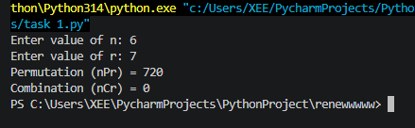

Task 2

large_number = lambda a, b: a if a > b else b

def print_table(num, limit):
for i in range(1, limit + 1):
print(f"{num} x {i} = {num * i}")
num1 = int(input("Enter first number: "))
num2 = int(input("Enter second number: "))
limit = int(input("Enter table range: "))
big = large_number(num1, num2)

print("\nLarger number is:", big)
print("Table of larger number:\n")

print_table(big, limit)

Result:

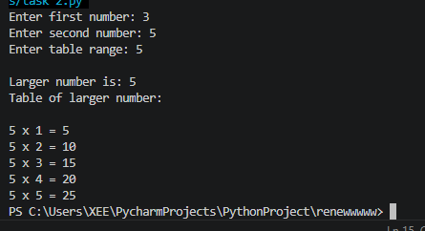

Task 3:
to_upper = lambda s: s.upper()

def invert(text):
return text[::-1]

text = input("Enter a string: ")

upper_text = to_upper(text)

print("Uppercase String:", upper_text)

reversed_text = invert(upper_text)

print("Reversed String:", reversed_text)
Result:

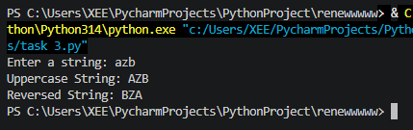

Task 4:
def celsius_to_fahrenheit(c):
return (c * 9/5) + 32

def fahrenheit_to_celsius(f):
return (f - 32) * 5/9

print("Temperature Conversion Program")
print("1. Celsius to Fahrenheit")
print("2. Fahrenheit to Celsius")

choice = int(input("Enter your choice (1 or 2): "))

if choice == 1:
c = float(input("Enter temperature in Celsius: "))
print("Fahrenheit =", celsius_to_fahrenheit(c))

elif choice == 2:
f = float(input("Enter temperature in Fahrenheit: "))
print("Celsius =", fahrenheit_to_celsius(f))

else:
print("Invalid choice!")

Result:

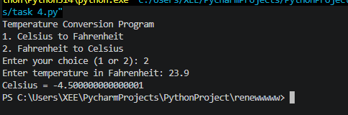

Task 5:
def calculate_gpa(courses):
total_points = 0
total_credits = 0

for gp, ch in courses:
total_points += gp * ch
total_credits += ch

if total_credits == 0:
return 0

return total_points / total_credits

n = int(input("Enter number of courses: "))

courses = []

for i in range(n):
gp = float(input(f"Enter grade point for course {i+1}: "))
ch = float(input(f"Enter credit hours for course {i+1}: "))
courses.append((gp, ch))
gpa = calculate_gpa(courses)

print("Your GPA =", round(gpa, 2))

Result:

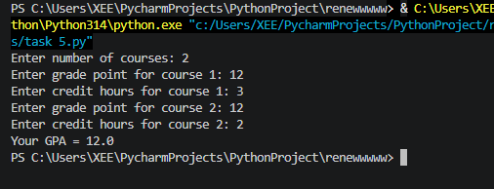

Task 6:

def calculate_gpa():
total_grade_points = 0
total_credit_hours = 0

n = int(input("Enter number of courses: "))

for i in range(n):
gp = float(input(f"Enter grade point for course {i+1}: "))
ch = float(input(f"Enter credit hours for course {i+1}: "))

total_grade_points += gp * ch
total_credit_hours += ch

if total_credit_hours == 0:
return 0

return total_grade_points / total_credit_hours

gpa = calculate_gpa()

print("Your GPA =", round(gpa, 2))

Result:
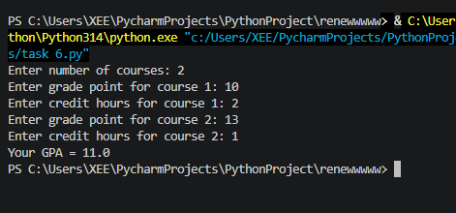

Task 7:
def n(name):
print(f"hello {name} , welcome to python")
n("ali")
n("sara")
n("ahmed")

Result:
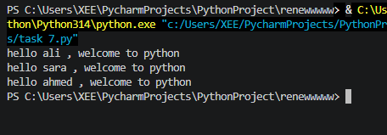

Task 8:
def sum(a,b):
return a+b
c=1
d=1
a=sum(c,d)
print(a)

b=sum(3,4)
print(b)

Result:
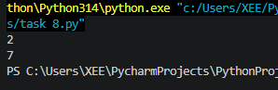

Task 9:
def a():
print("hello world")
print("hello world")
print("hello world")
print("hello world")
print("hello world")
print("hello world")
print("hello world")
print("hello world")
print("hello world")
print("hello world")
a()
a()
a()

Result:
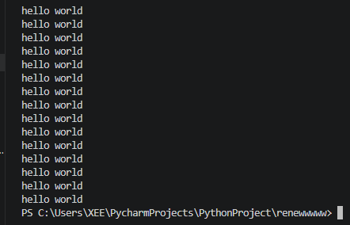

Conclusions:

In this lab, we learned how to create and use functions in Python. We also understood the importance of functions in reducing code repetition and improving program structure.

